Steve McTyeire 205-807-5200 SteveMcT@gmail.com NewLocationRealty.com
This acronym list and other study aids are on above website
RCA IS Zoning (districts)
Residential
Commercial
Agricultural
Industrial
Special Purpose

Supply Factors
Construction worker driving gold nail through White House into Federal Reserve
Labor Force
Construction cost
Government policies (Tax)
FED Financial policies (Monetary)

Test question will give 3 from one of these list and one from other
Demand Factors
Three people holding hands
1 Young – growing population
1 Old – Demographics of population
1 Unemployed – Employment Rates

Demand falls, Supply same, Prices fall
Supply falls, Demand same, Prices rise
There are lots ways to ask about supply and demand, be familiar with concept

Real Estate Characteristics
DUST
Demand
Utility
Scarcity
Transferability
Real Property Bundle of Rights -- Fee Simple Absolute has full bundle -- Freehold

UPEED
Use
Possession
Exclusion
Encumber
Disposition
Purpose of Real Estate Commission:
- Protect Public
B. Require license as proof of qualification
C. Regulate Business
Common test question will have above 3 plus a wrong answer like – D. enforce Fair Housing Law
Legal test of fixture
MARIA is attached
Method
Adaptability
Relationship of parties
Intention of parties
Agreement of parties

Total payment Conventional qualifying ratios 28/36 FHA 29/41 VA 41
It’s a PITI the payment is so high Front end # is total PITI (house payment) back end = total debt
Principle
Interest
Taxes
Insurance

Finance factor (look up on table by Rate% and time in years) times mortgage = principle and interest
5% for 30 years = factor of $5 per $1000 financed, $100,000 loan will be $500 per month P&I
Simple finance rule - $1,000 loan requires $5 per month repayment over 30 years
$100,000 loan will be $500 per month payment, requires about $500 weekly income
Types of Agency Relationships (Fiduciary)
Mr. Universe --King of the world – can perform duties under power of attorney as an attorney at fact
General in Army – can do things Mr. Universe delegates (Property Manager)
Specialist in Army – can do things general allows (Real Estate Agent)
Fiduciary Agency Responsibilities Work For - Advise
Can only be created by written agreement (Relationship starts as Transaction Broker – No Relationship)
Everyone is customer as Transaction Broker status until written agreement establishes Agency
Customers (non client) Answer the HARD ? Work With - Assist
Honest and Fair Dealing
Accounting
Reasonable Care
Disclosure of Material Facts
? Must answer questions truthfully and completely
Must also transmit all written offers immediately, prepare net sheet & disclose personal interest
Once Agency agreement is signed, either as listing or buyer agency agreements Agency is created
Agency Duties include above customer duties plus you must answer to the
COLonel
C Confidentiality
O Obedience
L Loyalty

Termination of Agency - Easy as ABCDEF
Agreement
Breach
Completion
Death of principle, Destruction of property
Expiration
Flaw Law (Bankruptcy)

Easement in Gross Utility line easements are “gross looking”
Appurtenant Easement runs with the land
Personal Easement does not run with the land

Water Rights
Riparian water rights have Ripples Small lake, River - Non-Navigable – Own to center of water
Littoral water is effected by Lunar – Large Lakes, Ocean – Navigable - Own to high water mark

Anti-Trust Violations _ Sherman Act
Price fixing
Group Boycotting
Market Allocation
Tie-in-agreements
Customer allocation

Government Powers PETE works for the government So does his sister Ginnie Mae
Police Power
Eminent Domain (Right to) Condemnation (Process of)
Taxation
Escheat (No Heirs)

Joint Tenancy (With right of Survivorship) Title passes to other owner at death
Normally Husband and wife ( doesn’t have to be husband and wife) are joined at the arm PITT
Possession - undivided
Interest – equal
Time – at same time
Title – one title

Tenants in Common – Swimming with the common people at condominium pool
100 unit condo each owner has 1% ownership in common areas
May sell their interest without effecting others. At death ownership passes to heirs

Adverse Possession 20 years
PANCHO must pay taxes

Possession
Adverse & Actual
Notorious
Continuous
Hostile
Open
Taxes

Contract Essentials COLA
Consideration something for something Valuable $ Good Love(family)
Offer and Acceptance
Legal purpose, Legal age .of parties, Legal capacity (mental)
Agreement between two or more people to do or not to do something
If contract transfers interest in real estate, it must be in writing to be enforceable
Lease
1 year or less, need not be in writing / 20 years must be in writing / 99 year maximum

Elements of a deed CEDDING (Cede means to transfer title)
Consideration [good ($) or valuable (love)] valuable love is between family members
Execution – signed by competent grantOR and two witnesses (or acknowledged – notarized)
Description of property
Delivery and acceptance by grantEE during lifetime of grantOR
Interest being conveyed
Names of grantOR and grantEE
Granting clause

Fair Housing – protected classes Civil Rights act of 1866 first to protect race
FRESH CORN
Famillial (family status) = with children, including being pregnant
Race
E Equal Opportunity for all
Sex
Handicap - Includes AIDS

Color
O E&O insurance doesn’t cover violation
Religion
National Origin

Equal Credit = Most of FRESH CORN + Age. Marital Status, Public assistance
A 99 year old divorced person on social security can get a 30 year loan if credit qualified

Risk Management Get monkey off your back
“I’m not an attorney, accountant, home inspector, or insurance agent, nor have I ever played one on TV”
ACTOR

Avoid
Control
Transfer
Or
Retain (Insurance)

Appraisals Opinion of value based on supportable evidence

CIA doesn’t want CBS watching them
When Comparable is Inferior, Add to its value (Not the subject’s value)
When Comparable is Better, Subtract from its value (Not the subject’s value)
e.g. Home next door has extra bedroom worth $10,000 - Subtract from its selling price to get subject’s value
Appraisers use three methods, below, and reconcile differences
Appraiser is a CSI Investigator
Cost Approach Special Purpose Structures
What it cost to rebuild - Best for new construction
Sales Comparison Approach CIA & CBS Best for residential
What other comparable properties have sold for recently
Income Income producing properties – apartments
Based on income and required return on investment Capitalization

CMA - Comparative Market Analysis - Based on Sales Comparison Approach – How you will determine price
Is not an appraisal, can not be called one, but is about what an appraiser does as one part of appraisal
Market Value = Opinion of Value May not have any relationship to cost to build or past sales price
Market Price = Actual sales price No relationship to cost
Cost = total of materials + land + labor + profit Renovations may not return cost (swimming pool)

Mortgage - Death Note 2 parts Promise to pay + Security Instrument
BorrOwer
DebtOr
MortgagOr Mortgage company is MortgagEE gets fee, mortgagOR gets door
TrustOr
PayOr

Real estate license required if you have a BARN SALE for someone besides parent, child or spouse
Buy
Auction
Rent
Negotiate

Sell
Aid
List
Exchange

No license required – my property, help parent, child, spouse, attorney doing attorney duties, authority – executor, sheriff sale, apartment manager, time share, cemetery lots
My Attorney has Authority as Apartment Manager to sell Time Share Cemetery lots

Metes(meters) & Bounds Pilgrims crashed into Plymouth Rock (first monument) became Point of Beginning
Rectangular or Government Survey (squares) Sections and Townships must state meridian referenced
Lot & Block (plat) subdivisions approved by and recorded in county

Acre = 43,560 square feet 208.71’ X 208.71’
Stop at the 7-11 store and ask how big an acre is 4+3, = 7 5+6 = 11 43,560
Mile = 5,280 feet Oak Mountain is 5 miles down Highway 280
Lot dimensions – Front foot is first number – Multiply front foot X depth to = square footage
Square footage of structure is Width X Depth– Home is 60’ across front & 40’ deep = 2400 square feet
Only heated and cooled areas are included, don’t count garage or porch

Section = 640 acres = 1 mile X 1mile Quarter Sections = 160 acres,
SW1/4 of SW1/4 of SW1/4 4X4X4 = 64 divides into 640 to find this property has 10 acres OR;
640/ 4 = 160/ 4 = 40/ 4 = 10 acres
To locate parcel, locate last part of description first and work backwards

<<<<<<<<Township Lines>>>>>>> & Base Lines (Run East and West) Tier every 6 miles
Range Lines run North & South every 6 miles intersecting with Township lines to form Townships
Township = 6 miles X 6 miles – Contains 36 sections Numbers start in NE corner
Birmingham is about T19S R4W Huntsville Meridian 19 township tiers south of Meridian & 4 ranges west
Must list meridian in legal description

Government Check corrects for curvature of earth - 4 townships X 4 townships, 24 miles square
Government Lots are the small parcels resulting from the government check adjustment

Listing Agreement must:
Be in writing
Have Expiration date
No automatic renewals

“T” Formula
________Results________ $10,000 Commission Paid
Base Rate $100,000 Sales Price .10 (or 10%) Commission Rate
Rate must be expressed as a decimal

Multiply bottom #s or divide top # by bottom # Base X Rate or Results / Base or Results / Rate
Results / Base = Rate 10,000 / 100,000 = .10
Results / Rate = Base 10,000 / .10 = 100,000
Results = Base X Rate 10,000 = 100,000 X .10

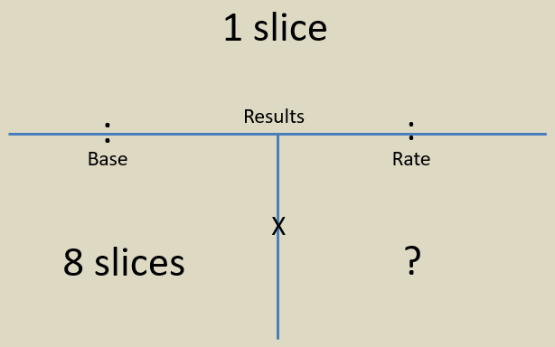
?
Commission
Rate
Sale
Price
Commission
Check

Commission
Check

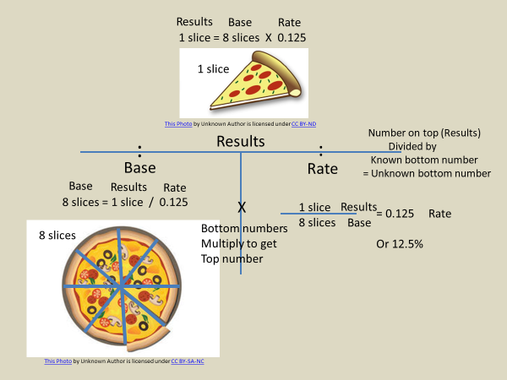
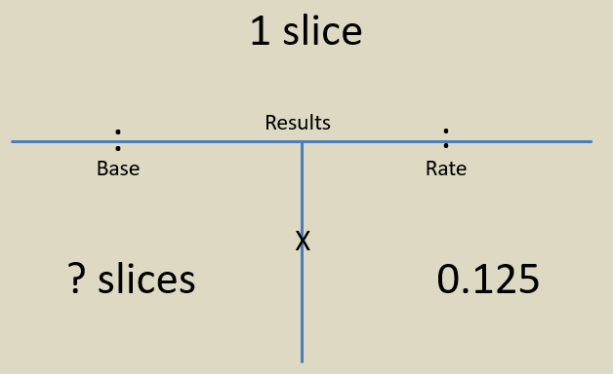
Sale
Price
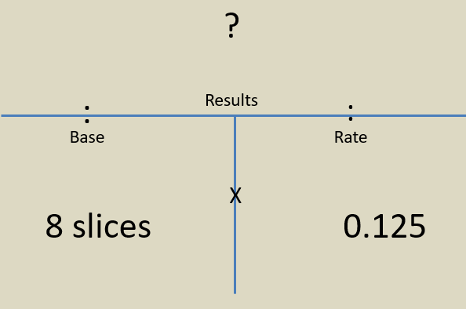
Commission
Rate

Capitalization Rate = Return on investment use “T” Formula
Investor demands a 10% Return, could be 15% or any number
Use this as the Rate in the “T” Formula - Must change to .10 Rate always goes on bottom right
You may not get the net income, but be given the numbers to calculate it
The way to calculate net income is GIVEN The test question may say:
GI $100,000 Gross Income: 100 apartments renting for $1000 per month
V - $5,000 Vacancy is 5% (of Gross Income) Test may give #
E - $30,000 Expenses are 30% (of Gross Income) Test may give #
N = $65,000 Net Income (Before Taxes)
These numbers are for one month, so multiply by 12 to get annual income = $780,000
$780,000 is the Result,(top #) you know the Rate (bottom right #) is .10 so now you need the Base (bottom left)
Divide the Net Income of $780,000 by the Rate of .10

_____________$780,000___________
$7,800,000 .10 = Capitalization Rate in the example is 10%

This apartment has a market value of $7,800,000 at a capitalization Rate of 10%
What if it sold for $5,000,000?
This means that the market (investors) require a higher rate of return of 15.6% Calculator said 0.156
With the “T” Formula, if you get an answer that look wrong, swap the Base # with the Result # and recalculate
7,800,000 / 780,000 would give a rate of return of 1000% and you would know that is wrong
Remember to move the decimal point two places to the right to get the % .10 = 10%
Alabama Law This is a third of the test. Spend time learning law
Know 31 Violations (34-27-36) subsections 1-31 These are on law handout
Also available on AREC.gov under law tab

Caveat Emptor “let the buyer beware” Alabama is last state
No law to affirmative (voluntary) disclose – Exceptions are written on your hand
HAND
Health & Safety – Known defect – no duty to discover
Assumption of Duty - Buyer’s Agent has duty to disclose everything known
New Construction - Expectation that everything works as advertised – builder’s warranty
Direct Question - Does the roof leak? If so, you must answer truthfully

Any used property sold “as is” is sold “as is, period” This precludes all fraud claims unless:
- There was a material defect which adversely affects health or safety;
- The seller or seller’s agent knew of the defects before the sale;
- The defect was such that it could not be discovered by due diligence; and
- The house was not bought “as is”
Advertising (all), including web
- Do not publish any false or misleading advertisement;
- Do identify yourself as a licensed broker or salesperson;
- If you are a salesperson or associate broker and your name appears in an ad, then the ad must prominently contain the name of the qualifying broker or company name.
RECAD Real Estate Consumer Agency Disclosure Alabama law
Must be presented as soon as reasonably possible, your copy must be retained for 3 years
Before any confidential information is disclosed to another

RESPA Real Estate Settlement Procedure Act Federal law
Protects consumers from being overcharged for settlement services (NO Kickbacks)

Constructive Notice is Recorded in county where property is located Liens on public display
Actual Notice Actually drive by house and will see someone in possession
Deed is not proof of ownership shows transfer
Alabama is “title state” gives title to mortgagee Owner (mortgagor) gets equitable title
Equitable right of redemption is before the foreclosure sale
Statutory right of redemption is for 12 months after foreclosure sale
First mortgage is second in line to collect money, right after property taxes in foreclosure sale
If there is no money left over, all junior liens are extinguished and buyer get clear title
Tax Certificate is when county sells a certificate for the tax owed on property
May be redeemed within 3 years. Clear title 7 years

